Combining Image Analysis and Process Modelling to improve healthcare

a report by Renate van Kempen | B.A.I.M.E (Business A.I. Made Easy)

# Meet our patient

Mike takes a seat in the doctors office. While he had hoped for good news, his doctor is telling him that he is diagnosed with Cancer. The doctor struggles to explain him what the exact findings are and how the treatment would look like, so Mike imagines the worst case scenario and starts crying…

Of course, news like this has great impact. The patient might not be able to grasp what is happening, as he is still dealing with the first sentence spoken; “I have bad news for you…”. What if the doctor could easily interpret the images taken during all the scans and was able to hand Mike a schema with the best possible outcome and a clear path on how to get there with time lines. Than they could walk through his treatment with a clear visualization and help Mike to get the best possible outcome.

# Image analysis

In order to help Mike to get a clear and useful diagnose and treatment plan, we first need to use image analysis to interpret the images correctly and not make mistakes in the diagnoses.

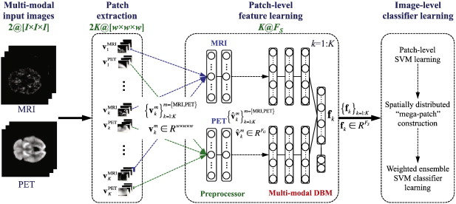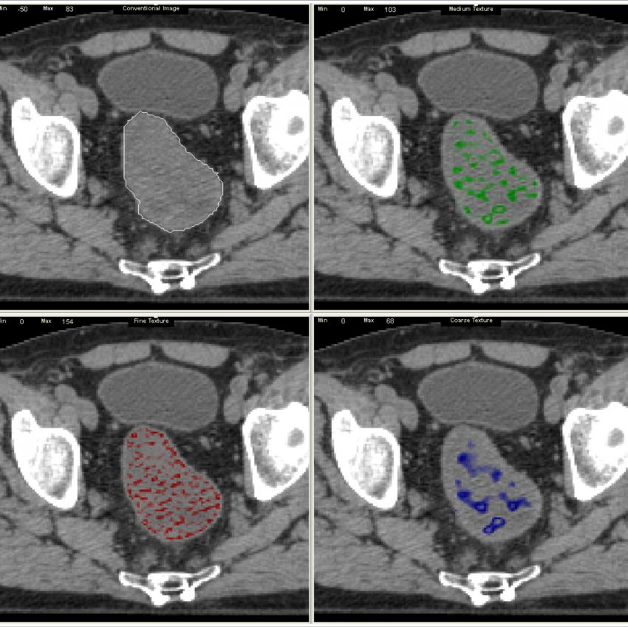We want compare the photo’s and video’s made in the scans to see in what stage the cancer is in and where it is located in his body, whilst comparing it with a test image dataset.

In order to do a good and profound image analysis, we need to use the newest vision A.I. techniques, such as YOLO v4 and GPT-3. And of course, use the image database in the Data Safe Haven in Scotland. Always making sure we anonymize patient information with respect to both the person as well as the law (GDPR)

To set up the model, we first train the model with the test images, but withhold a threshold of 30% to test the model on. To make sure we get the best possible accuracy (over 90%), we would varying various parameters, such as using hybrid segmentation and classification techniques such of multi-level classifiers, the features to be extracted and improvement in noise removal. And we would combine different algorithms, such as pixel level classifications with support vector machines and K-nearest neighbors algorithm.

The negative side of such analysis is that we would never reach a model with an accuracy of 100%, making it impossible to always set the correct diagnose or treatment path for a specific patient. To ensure that we increase our accuracy, we must use re-inforcement learning techniques to train the machine learning algorithm.

# PRocess Modelling

We could use a process modelling visualization to show a specified treatment for Mike, based on the stage his cancer is in. This way the doctor has a clear visual to provide Mike, with all the different steps indicated, which he can take home.

Of course, this process needs to be carefully followed and for each step with multiple options, we should carefully implement the history on all treatments combined with the exact information on the cancer of the patient to see what option would be the best to use in this specific case. This we should also store, and reflect if the outcome was the same as predicted.

The model to use could be a neural network model to get the best network according to the provided input and output experimental data. The downside is that neural networks are like a blackbox, we do not know what the model does exactly. Or we use Petri net, which is a very graphical discrete modeling technique in which the network nodes are not biological entities but conditions and events. Directed interactions connect the different conditions, going through one or several event(s) or transition(s).

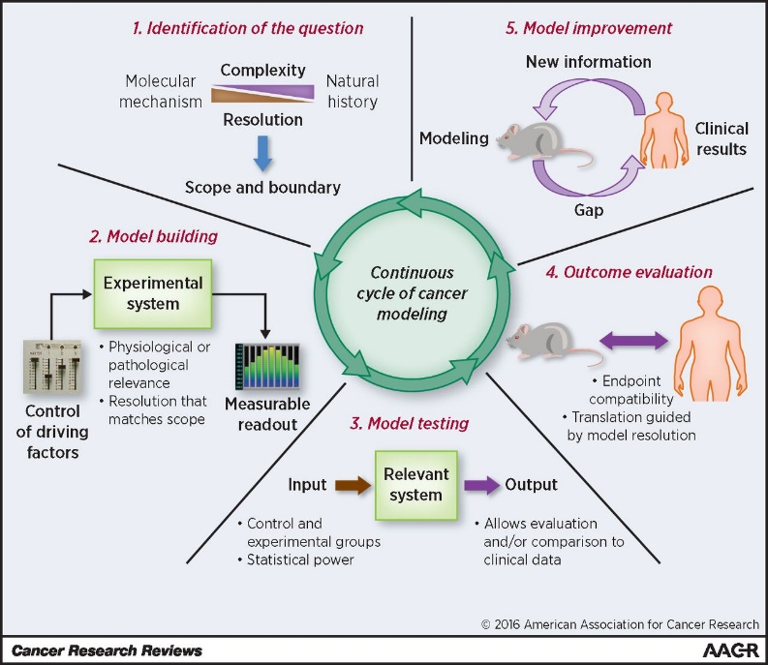Also here we should optimize the model to choose the best possible option with a high confidentiality rate. And similar to the image model, we would never reach 100%, but need to be pretty damn sure that we are as close to this as possible, as we are treating a person here.

# Super power through combination

Now we have seen how we can use Image Analysis to set the right diagnose and process modelling to give a clear treatment path to Mike, we only get a superpower if we combine the two.

If we know how a patients treatment looks like, and we know what images start which treatment process, which we have optimized during to get the best possible outcome, we could combine the two to see if we could help out all global hospitals with a set treatment path for a specific diagnose. This would need to be proven through thorough research off course, but we could have a potential superpower here. This way a patient could avoid making the same mistakes in a treatment that a previous patient has endured already. If we would emphasize on the successes, we could help more patients, such as Mike get the best possible outcome!